Preparation Manuscript Proceedings (Font18, Times New Roman)
(Two spaces)

First Author^{1*}, Second Author^{2, …} (Font10, Times New Roman)
¹ Affiliation and Short Address
² Affiliation and Short Address
(One space)
*(corresponding author email address:)
(Two spaces)

Abstract- Abstract is also a concise summary of the study and the second mostly read portion of a paper. The summary of your work should not exceed 100 words. It should be a single paragraph. (bolded, font10, Times New Roman)
(two spaces)

Keywords - About four key words or phrases in alphabetical order, separated by commas (font10, Times New Roman)
(one space)
- Introduction
Introduction is the starting part of your paper and is also important. However, your introduction part should not exceed half a page. The first paragraph should start with a broad statement and then narrow down to the research topic on the rest of the paragraphs.
(One space)
- Materials and methods
(One space)
The purpose of writing this section is to present the work method or study method, the materials and devices used (in laboratory research) and the entire path that is followed until the goals and assumptions finally reach a specific result.

- RESULTS, DISCUSSION and Conclusion
(One space)
In this part, the results of the research are expressed and discussed. Usually, the use of charts, numbers, and tables makes it easier for the readers of the article to understand the content. In this section, the graphs and tables that are mentioned should be fully explained.

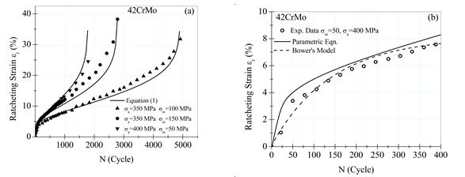
Fig. 1: (a) Please see the symbols in the figure use common symbols which widely used. (b) Provide references if data has been extracted from literature

TABLE I: Mechanical Properties
(One space)
Material | E (GPa) | σ_{y} (MPa)
304 steel | 190 | 209
42CrMo | 190.5 | 310
316L steel | 190 | 285
Copper | 129 | 60
(One space)
Figure captions should be centered below the figures; table captions should be centered above. Avoid placing figures and tables before their first mention in the text. Use the abbreviation “Fig. 1,” even at the beginning of a sentence.
(One space)
  - References
Number the citations consecutively in square brackets [1]. Punctuation follows the bracket [2,3]. Give all authors’ names if there are two; use “et al.” if there are three authors or more. Papers that have been submitted or under review should not be cited. Papers that have been accepted for publication should be cited as “in-press”. No paper title is required.

  - Abbreviations and Acronyms
Define abbreviations and acronyms the first time they are used in the text, even if they have been defined in the abstract. Do not use abbreviations in the title unless they are unavoidable.
(One space)
  - Equations
Number equations consecutively with equation numbers in parentheses with the right margin. Italicize Roman symbols for quantities and variables, but not Greek symbols. Use parentheses to avoid ambiguities in denominators. Punctuate equations with commas or periods when they are part of a sentence:

a + b = c. (1)

Symbols in your equation should be defined before the equation appears or immediately following. Use “Eq (1)” not “equation (1),” except at the beginning of a sentence: “Equation (1) is …”
(One space)
  - Other Recommendations

Use either SI units as primary units. An exception would be the use of English units as identifiers in trade, such as “3.5-inch disk drive”.
(One space)
Acknowledgment
(One space)
Acknowledgments are made briefly to those contributing to the research in a sentence or two.
(One space)
References
- R. Ebrahimi and A. Najafizadeh,”A New Method for Evaluation of Friction of in Bulk Metal Forming", Journal of Materials processing Technology, 152, 136-142.
- M. H. Paydar and M. Raoufi, “Mechanochemical Carbothermic Reduction of Ilmenite”, 10th Word Conference on Titanium, Homburg-Germany, July 2003, 269-275.
- Y. Sun, Ph. D. Thesis. University of Birmingham. 1989.
Attention: The reference can also be applied by Endnote with Numbered style.

